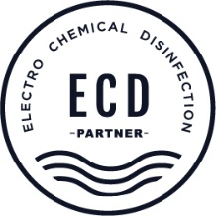**Become an ECD®partner**

Thank you for your interest,

As an ECD® partner, you are part of the growing group of people, firms and institutions that are helping to make the transition from chlorine disinfection to electrical disinfection.

ECD® technology and ECD®-based devices are only sold and distributed to and through ECD® partners. This allows us to give assurance to all customers that the technology is being applied correctly.

Moreover, this also protects you from anyone wanting to bring so-called alternatives onto the market without proof of operation via long-term pilot projects in public pools.

We would love to have some more info about you and/or your organisation. You can already provide this in the form below.

We will then get in touch.

|  |  |
| --- | --- |
| **GENERAL INFORMATION** |  |
| Organisation / name |  |
| Street and number |  |
| Postal code and city |  |
| Contact person |  |
| Function |  |
| E-mail |  |
| Tel. |  |
| Other persons or bodies involved |  |
| **TYPE** |  |
| Design office / architect |  |
| Pool builder |  |
| Installer |  |
| Other: … |  |
| **MARKET** |  |
| Public and commercial pools |  |
| Hotel / sauna / health centre |  |
| Private |  |
|  |  |
| **REFERENCES** |  |
| **ADDITIONAL INFO ?** |  |

Stef Desmet

Commercieel directeur Novinato

0032 475 98 56 18

[Stef.desmet@novinato.com](mailto:Stef.desmet@novinato.com)